
JKKI: Jurnal Kedokteran dan Kesehatan Indonesia
Indonesian Journal of Medicine and Health
Journal homepage: https://journal.uii.ac.id/JKKI
P-ISSN 2085-4145 | E-ISSN 2527-2950
Title of the article, written in Cambria font, size 14, bold, single-spaced, maximum 20 words: Subtitle can be used to explain a long title, avoid non-standard abbreviations
First Author,*¹ Second Author,² Third Author²
¹Department of X, Faculty of Y, University of Z, Province, Country
²Department of A, Hospital B, Province, Country
Article Info: | Article History:
Keywords: keyword 1; keyword 2; keyword 3; keyword 4; keyword 5 | Received:  Accepted:  Online:
*Corresponding author:  email@email.ac.id | DOI:
Case Report

ABSTRACT
Consist of a unstructured abstract that contains 150-300 words, typed in single-space and written in font Cambria size 11. Abstract should consist of and introduction that mention what is unique about this case and what does it add to the scientific literature. The case presentation, including the main symptoms and/or important clinical findings, the main diagnoses, therapeutic interventions, and outcomes. The last part of the abstract is the conclusion, that contains what is the main “take-away” lesson(s) from this case.

INTRODUCTION
The introduction consists one or two paragraphs summarizing why this case is unique, interesting or important to be reported. In the text, citation can be written at the end of the sentences using the Vancouver style.¹ This section should be written without subtitles.² Authors can be also stated in the text, for example a study by Sulistyoningrum et al. (2015) stated that introduction for a case report is recommended to be written in 1-2 paragraphs length neither too long nor too short.³ Also this section must state the report contribution of the current condition to the health and medicine development in Indonesia, and emphasize its importance to Indonesia. Finally, the authors must briefly mention the main aim of their case report.

CASE DESCRIPTION
The authors should describe relevant patient information, clinical findings, timeline, diagnostic assessment, therapeutic intervention, follow-up and outcomes.
Patient information: This part illustrates patient demographic information (e.g.: age, gender, ethnicity, occupation), main symptoms of patients (his or her chief complaints), medical records, family, and psychosocial history. Also it can include their diet, lifestyle, possible genetic information, and details about relevant comorbidities including past interventions and their outcomes.
Clinical findings: This part describes significant physical examination and important clinical findings.
Timeline: This part conveys historical and current information from an episode of care organized as a timeline.
Diagnostic assessment: This part includes laboratory testing, imaging, questionnaires, diagnostic challenges (e.g.: access to testing, financial factors, languages or cultures), diagnostic reasoning including other diagnoses and prognostic characteristics (e.g.: staging) if applicable.
Therapeutic intervention: This part includes types of therapeutic intervention (such as pharmacologic, surgical, preventive, or self-care intervention), administration of therapeutic intervention (such as dosage and strength duration), and changes in therapeutic intervention (with rationale).
Follow-up and outcomes: This part summarizes clinical courses of all follow-up visits including both- clinician and patient- assessed outcomes, important follow-up test results (positive or negative), intervention adherence and tolerability (and how this was assessed), and adverse and unanticipated events.
Maximum number of tables and/or pictures are 6 in 1 manuscript.

Tables
The tables should be numbered in the text sequentially, written in single-space with Cambria size 10 (Table 1). The table title should be precise, clear, and located above the table. Please do not use internal horizontal or vertical lines; the border is only used in the column headings and the end of the tables. The tables must be placed after they were discussed in the text.
Table 1. Reporting guidelines to report main study types
Study types | Recommended reporting guidelines | Useful links
Randomised trials | Consolidated Standards of Reporting Trials or CONSORT | https://www.equator-network.org/reporting-guidelines/consort/
Observational studies | STrengthening the Reporting of OBservational studies in Epidemiology or STROBE | https://www.strobe-statement.org/
Diagnostic/prognostic studies | Standards for Reporting of Diagnostic Accuracy (STARD) | doi: 10.1007/s11606-008-0583-3
Diagnostic/prognostic studies | APPRAISAL OF GUIDELINES FOR RESEARCH & EVALUATION II (AGREE II) | doi: https://doi.org/10.1136/bmj.i2027
Qualitative research | Standards for Reporting Qualitative Research (SRQR) or  Consolidated criteria for reporting  qualitative research (COREQ) | 0.1093/intqhc/mzm042  DOI: 10.1097/ACM.0000000000000388
Animal pre-clinical studies | ARRIVE (Animal  Research: Reporting of In Vivo Experiments) | DOI: 10.1371/journal.pbio.3000410

The authors should place explanatory matter in footnotes, not in the heading. If the tables contain numbers, please use (.) to separates decimals (limited to only 2 decimals). Any statistical values should be written in 3 decimals. Any symbols must be placed properly and described in the caption (Table 2).

Table 2. Elements of benefits of implementing MSS health in Lumajang Regency
Compound name | Assay/method |  | Targeted DENV serotype and cell line used | Study parameters
Quercetin⁵³ | MTT assay, RT-PCR, molecular docking | DENV-2 strain NGC, Huh7it-1 |  | - IC₅₀= 1.1 μg/ml  - CC₅₀= 38.8 μg/ml  - SI= 38
Isobutyl gallate⁵⁴ | MTT assay, FAA | DENV-2 strain New Guinea C (NGC), Huh7 it-1 |  | - CC₅₀= 167.19 µg/mL  - IC₅₀= 4.45 µg/mL  - SI= 25.69
Curcumin⁴⁵ | MTT assay, plaque assay | - Virus: DENV­1 strain JMB­034, DENV­2 strain SUB­011, DENV­3 strain SUB­006, and DENV­4 strain SUB­007  - Cell line: alveolar epithelial carcinoma A549, fibroblast BHK­21 |  | - IC₅₀=20.60 µM (DENV-1); 13.95 µM (DENV-2); 25.54 µM (DENV-3); 12.35 µM (DENV-4)  - CC₅₀= 108 µM
6-gingerol⁴⁵ | MTT assay, plaque assay | - Virus: DENV­1 strain JMB­034, DENV­2 strain SUB­011, DENV­3 strain SUB­006, and DENV­4 strain SUB­007  - Cell line: alveolar epithelial carcinoma A549, fibroblast BHK­21 |  | - IC₅₀= 14.70 µM (DENV-1),14.17 µM (DENV-2), 78.76 µM (DENV-3), 112.84 µM (DENV-4)  - CC₅₀= 210 µM
MSS: Minimum Service Standards

Figures
Figures should be professionally drawn. photographed or submitted as high-quality digital prints. They also should be sequentially numbered and provide information related to their results that are presented in texts without duplication. Important points in the figures must be annotated and described in the caption or figure legend, which should be written in Cambria size 10. Histological pictures must be accompanied by the staining method and magnification (Figure 1).
Initial submissions do not require high-resolution image files, but images must be of sufficient resolution for reviewers to properly evaluate the data. It is suggested that they must be incorporated with the manuscript text into a single Word document at initial submission, but separated image files may be supplied if necessary. Should your manuscript be accepted, you will receive more extensive instructions for final submission of display items. However, some guidelines for the preparation of final figures are provided below if you wish to minimize subsequent revisions and potential delays. The images should be in RGB colour and at a resolution of 300 dpi or high. The authors should use the same typeface (Cambria) for all figures.

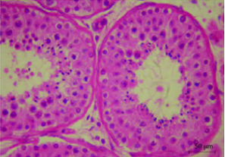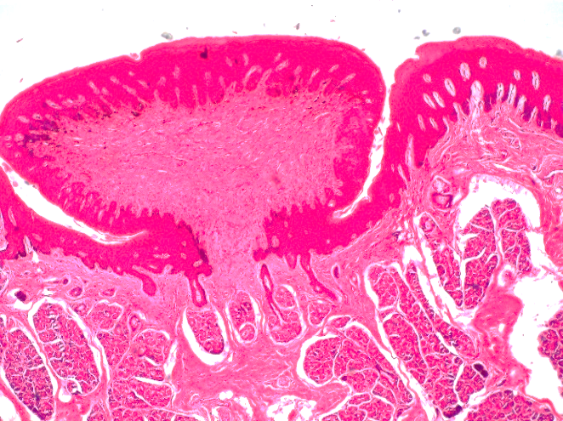
A
B
Figure 1. Some examples of histopathological pictures. A. tubuli seminiferi with germinal epithelium (red arrow), B. lingual papilla with von Ebner gland (black arrow). Haematoxylin-Eosin staining, 400X magnification

One figure can be explained as a maximum of four relevant figures. The title of the figures should be short and clear and located below the image. Important points in the figure must be annotated and described in the caption or figure legend, which should be written in Cambria size 10. Statistical figures should be equipped with axis titles (Figure 2).

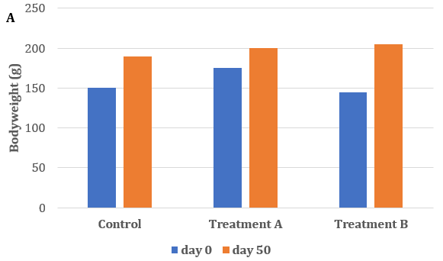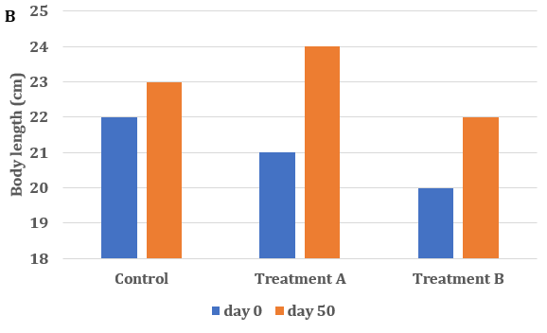
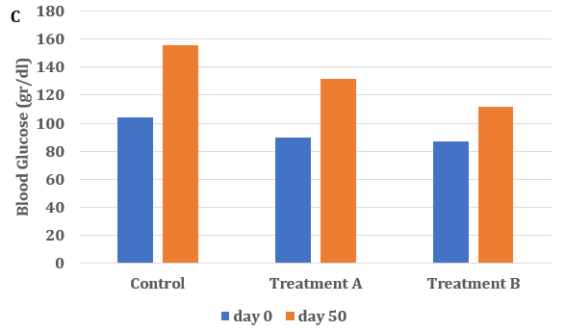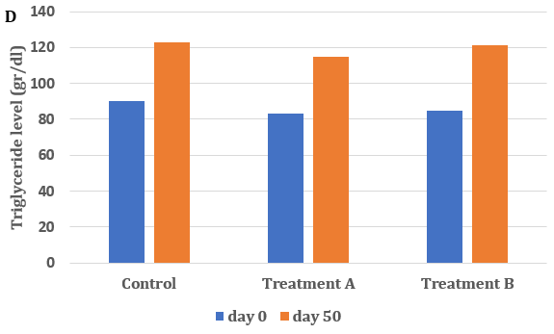
Figure 1. Comparison of anthropometric and biochemicals parameters among groups before and after treatment. A. Bodyweight, B. body length, C. Blood glucose level and D. triglyceride level

DISCUSSION
This section must include a scientific discussion of the strengths and limitation associated with the case report. The discussion also consist of the relevant medical literature, the rationale for conclusions (including assessments of causes and effects), and the main “take-away” lessons of this case report. Review of literature should be appropriate and closely related to the case; it must be rooted in the study of literature to provide a summary as a basis for discussion. The discussion should not be written in subtitles. Also, the authors should state the implication of the study to the SDG.

CONCLUSION
This section consists of conclusions and suggestions in one paragraph. The conclusions should be the answer of research problems, without unequivocal statement. The suggestions should be logical and appropriate.

CONFLICT OF INTEREST
The authors should make a conflict-of-interest disclosure statement or a declaration that they do not have any conflicts of interest. They should disclose at the time of revision any financial arrangement they may have with a company whose product is pertinent to the submitted manuscript or with a company making a competing product. Such information will be held in confidence while the paper is under review and will not influence the editorial process. They also should declare that the patients have given informed consent for publication.

ACKNOWLEDGMENTS
In this section, the authors can acknowledge any support given. Anyone (individual/company/institution) of important intellectual content who has substantially contributed to the study must be acknowledged. The acknowledgement is only for persons who have made substantive contributions to the study. This section may also include funding. This may also include administrative and technical support, or donations (e.g., materials used for experiments).

DATA AVAILABILITY STATEMENT
The authors are required to include a data availability statement in their manuscript. The data availability statement should clearly explain where the data supporting the research findings can be accessed. If the data are not publicly accessible, the authors must provide a clear reason and explain how to obtain access if upon request.

SUPPLEMENTARY MATERIAL(S)
Data that are not critical to the text or cannot be included in the article due to size or format restrictions can be uploaded as supplementary material during the submission process and displayed alongside the published article.
Supplementary material is not typeset; therefore, the authors must ensure that all information is clearly presented without tracked changes/highlighted text/line numbers, and that the appropriate caption is included in the file.

AUTHORS CONTRIBUTIONS
A paragraph should be included explaining how each author contributed to the manuscript. Names of the authors should be expressed as initials.

DECLARATION OF USING AI IN THE WRITING PROCESS
A paragraph should be included explaining how the author(s) used AI and AI-assisted technologies in the writing process if any.

LIST OF ABBREVIATIONS
UDCA: Ursodeoxycholic Acid; MMP-9: Matrix Metalloproteinase-9; TIMP-1: Tissue Inhibitors of Metalloproteases-1; HSC: Hepatic Stellate Cells; BDL: Bile Duct Ligation; TNF-α: Tumor Necrosis Factor-α; TGF-β1: Transforming Growth Factor-β1; α-SMA: α-smooth muscle actin

REFERENCES
References must be numbered consecutively in the order in which they first appear in the text (including citations in tables and legends) and listed individually at the end of the manuscript. The authors are recommended to prepare the references with a bibliography software package, such as EndNote, Reference Manager or Zotero to avoid typing mistakes and duplicated references. If you use the Mendeley Reference Manager, please use this link to write the References (https://csl.mendeley.com/styles/515400891/Jurnal-JKKI). The reference were not allowed from repositories, unpublished research or unofficial websites. For further information, please refer to the author’s guidelines.

In the text, reference numbers should be placed in superscript and placed after the punctuation. In the reference list, the references should include the names of all authors when six or fewer; when seven or more, list only the first six names and add “et al.” The references should also include full title and source information (Vancouver style). Journal names should be abbreviated as in MEDLINE.

- Winarno ANS. Kerley a line in an 18-year-old female with acute pulmonary edema and chronic kidney disease stage V. JKKI. 2017;8(1):38–44.
- Ouchi Y, Rakugi H, Arai H, Akishita M, Ito H, Toba K, et al. Redefining the older people as aged 75 years and older: Proposal from the Joint Committee of Japan Gerontological Society and the Int J Ger. 2017;1045–7.
- Diabetes Prevention Program Research Group. Hypertension, insulin, and proinsulin in participants with impaired glucose tolerance. Hypertension.2002;40(5):679–86.
- Lewis G. Why Mothers Die. Report on confidential enquiries into maternal deaths in the United Kingdom, 2000-2002. Lewis G, editor. London: RCOG Press; 2004.
- Lock S. Death in Childbirth: An International Study of Maternal Care and Maternal Mortality 1800-1950. London: Oxford University Press; 1992. 338–339. p.
- Council of Europe. Recent Demographic Developments in Europe 2004. Strasbourg, France: Council of Europe Publishing; 2005.
- Desrini S, Ghiffary HM. Comparison of antibacterial activity of Talok (Muntingia calabura L) leaves ethanolic and n-hexane extracts on Propionibacterium acnes. In: AIP Conference Proceedings. 2018.
- Singh S, Henshaw SK, Berensten K. Abortion: a worldwide overview. In: Basu AM, editor. The Sociocultural and Political Aspects of Abortion: Global Perspectives. Westport: Praeger Publishers; 2003. p. 15–47.
- U.S. Bureau of the Census. International Data Base [Internet]. China; 2007 [cited 2009 Aug 12]. Available from: http://www.census.gov/ipc/www/idb/country/chportal.html

